Biology Hour_____ Name__________________________________________________
Wexler/Fennelly
DNA Structure Worksheet
Date:
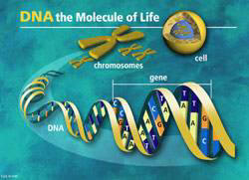
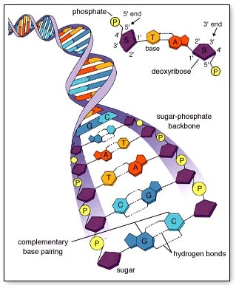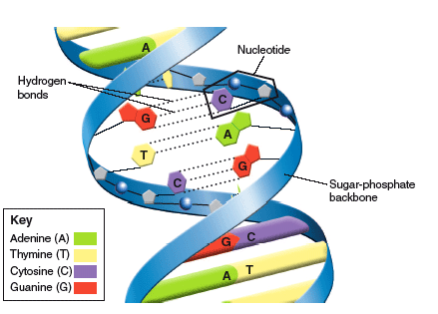
1. What do the letters DNA stand for?
2. Two scientists are given credit for discovering the structure of DNA. What are the name of those two
scientists?

3. DNA is a polymer, which means that is made up of many repeating single units (monomers). What is the general name for this type of monomer?

4. The “backbone” of the DNA molecule is made up of two components. What are these?

5. There are four different variations of the monomers comprising DNA (four different bases). What are the names of those bases?
A.
B.
C.
D.
6. These bases are of two different types: purines and pyrimidines. The major difference between them is that purines have _________ ring(s) in their structure while pyrimidines have __________ ring(s).
7. The two purine bases are:
8. The two pyrimidine bases are:
9. According to the complementary base-pairing rules, ________________ pairs with _________________, and _________________ pairs with ____________________
10. How many strands of DNA make up a single molecule?
11. What kind of bond holds the two complementary DNA strands together?
12. What is the term for the shape of a molecule of DNA?

13. Rosalind Franklin and Maurice Wilkins studied the structure of DNA using a technique called:

14. What are the three parts of a nucleotide?

15. Draw the basic structure of a nucleotide with its three parts:

16. Write the complementary sequence to the following DNA strand. Include the 5’ and 3’ ends.
5’ AATTCGCCGGTATTAGACGTT 3’

18. Use the diagram below to complete the following:
A. Circle one of the nucleotides, including its three parts
B. Label a sugar
C. Label a phosphate
D. Write in the bases that are not already labeled in the diagram.
