Name_________________________________________ Hour_____ Date________

RIVERSIDE
FOREST SCAVENGER HUNT

Give one example of each item listed below that you find during your nature walk. (If you don’t know what it is, than draw it).

Species:

Population:

Community:

Ecosystem:

Biome:

Decomposer:

Herbivore:

Carnivore:

Look under a rotted log, list 3 biotic factors that you see:
-
-
-
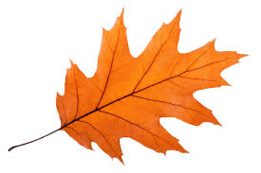
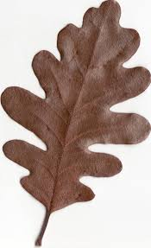
Oaks provide habitats for many species in certain areas. Find a Oak tree, what are two animals you see living on this tree?
-
-

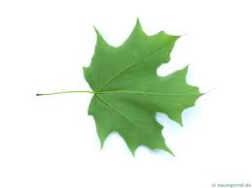
Sugar maples of the hardwood forests bring water from lower levels in the ground that helps other plants. It is also home to many insects, birds, and small animals. Describe or draw some of the plants you see surrounding the sugar maple.

Bees pollinate plants, contributing to the plant's survival. The plants are shelter for insects, which are then eaten by other species, like birds. In which biome that you explored are you most likely to find bees?

List 3 biotic factors and 3 abiotic factors you see near the river.
- -
- -
- -

North American Beavers (Casor candensis) are considered habitat engineers because they change the environment by building dams. This dam building provides still water in which many species flourish. At the boat launch near the river, there is evidence that beavers were in this area. What evidence did you find?

Coyotes have a regulatory effect on smaller predator (mesopredator) populations, which allows prey of the smaller predator species to survive. Look around, and list 3 animals likely to benefit from coyotes.

