Name______________________ Hour____________________
The Fibonacci Sequence in Nature and Art
Note: you will need a calculator for this activity.
Part I. Fibonacci Numbers
Fibonacci numbers appear mysteriously in many forms in nature, from seed spiral numbers in sunflowers and pine cones to flower petal numbers as seen below:
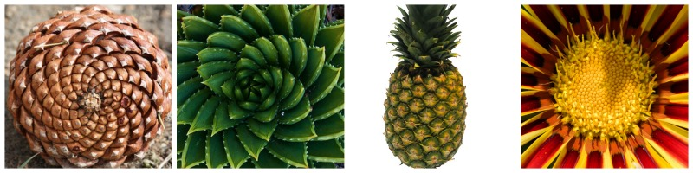
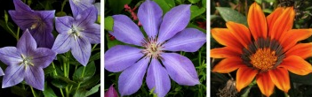
1 2 3

- List the Fibonacci numbers from low to high by filling in the spaces from left to right:

0 1 1 2 3 _____ _____ _____ _____ _____ _____

- Describe in your own words what forms the pattern of the sequence:

- Look at the pine cone above: how many clockwise spirals can you count? ________ Is this a Fibonacci number? _______

- What are the flower petal numbers from left to right? Are they Fibonacci numbers? ______
Flower 1)
Flower 2)
Flower 3)

Part II. The Golden Ratio
The golden ratio is a mathematical proportion between successive numbers in the Fibonacci sequence.
- Describe in your own words how the Golden Ratio is calculated:

- Divide the last number in the sequence of part IA by the next to last number.
What do you get? __________
This is the Golden Ratio.
- Circle rectangle below that is most likely to exhibit the Golden Ratio:

- Which of the rectangles above is most likely to be the shape of a painting hanging in a museum?
(left or right)

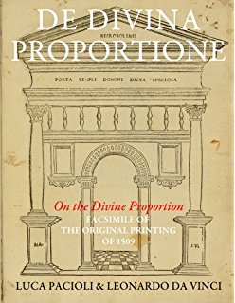
Part III. The Golden Ratio in Art
Artists from the Italian Renaissance such as Leonardo Da Vinci and Michelangelo were well aware of the importance of the golden ratio to our sense of beauty and incorporated this proportion in their art and architecture. In fact, Leonardo drew the illustrations for La Pacioli’s book called “On the Divine Proportion” written in 1498.
Follow along with the Powerpoint which shows several paintings by artists known to use the golden ratio in their art. Keep in mind that the golden ratio are unconsciously incorporated in art because the human mind is mysteriously adapted to consider this proportion well-balanced and harmonious.

Instructions:
Each of the first three paintings has two or more measured lengths. Your job is to determine if the ratio between these lengths approximates the golden ratio of 1.618.
Painting 1: Michelangelo’s “The Creation of Adam”
- Calculate the ratio along the horizontal plane aligned with the outstretched arms of God and Adam

- Calculate the ratio between the heights of the region below the arms to the region above the arms.

- Are these two ratios close to the golden ratio? (note: they don’t have to be exact).

- There appears to be one Golden Rectangle among the 4 rectangles in this composition. Which do you think it is (lower left, lower right, upper left, or upper right) and support your decision by calculating the ratio of length to height for that rectangle. Is it close to the golden ratio?

Painting 2: Botticelli’s “The Birth of Venus”
- The horizontal line divides the sea from the sky in this painting. Calculate the ratio of the sea to sky:

- The vertical line separates the wind gods Zephyr and Aura from Venus, who is blown to shore on a scallop shell to be clothed by one of the Horae, a minor goddess and attendant to Venus, the goddess of love. Calculate the horizontal ratio between these two regions.

- The body cylinder for Venus forms a golden rectangle between her shoulders and navel. Show this by calculating the ratio of the two dimensions of this rectangle.

Painting 3: Cezanne’s “La Montagne Sainte-Victoire”
Actually this is one of a series of paintings of the mountain. Cezanne was a groundbreaking painter who inspired a new generation of artists by connecting the optical effects of late 19th century impressionism with the abstraction of “geometric essentials” leading to the abstract art movement of the early 20th century. Cezanne was well aware of geometric proportions and used them in much of his art. The golden ratio is used rather precisely in this painting to separate background and foreground elements.
- Calculate the ratio of green middlescape to blue sky/mountain.
- Calculate the ratio of green middlescape to blue foreground.

Painting 4: Cezanne’s “Bay of Estaque” – observe that the absence of the use of the golden ratio gives the painting an unbalanced feeling.
Painting 5: A Jackson Pollack drip painting (“Jack the Dripper”). The canvas itself forms a golden rectangle but otherwise the painting lacks form.

