Biology Hour_____ Name_________________________________________
Wexler/Fennelly
Lab: Is Yeast Alive?
Start Date:

- Background and Purpose:
Baker’s yeast, or Saccharomyces cerevisiae, is used by humans for a variety of purposes, including baking bread, beer and wine-making, and ethanol production for fuel.

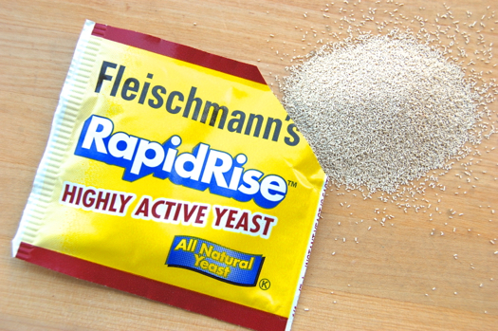

Packaged yeast is freeze-dried for storage. It can sit on your shelf for months, in your refrigerator for a year, or frozen for many years before they die.

The granules found in the package contain the dried yeast. There are other ingredients that help it survive in a dried state and also make it convenient to measure.

How can you prove that the dried yeast is really alive? After all, living things require water to live.

Claim, Evidence, and Reasoning: If you can show that the yeast have the characteristics of living organisms, then you can conclude that it is alive.

As you may recall, the 7 main characteristics of all living things are as follows:

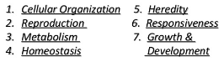

You will perform a series of tests that will provide evidence for four of the above characteristics. You will examine the evidence and provide reasons why that evidence supports the existence of those characteristics: growth & development, cellular organization, metabolism, and reproduction.

- Criteria:

- Growth & development
If an organism increases its size and/or changes its characteristics with age then we say that it has grown and/or developed. You can see this as infants grow and develop over time into adults that are both larger and very different-looking.

- Cellular organization
An organism may be unicellular or multicellular in its organization. Humans are multicellular. Yeast, on the other hand, are unicellular. A yeast cell is oblong in shape and is bounded by a lipid membrane covered with a tough layer (cell wall) of chitin, a carbohydrate similar to cellulose and which is also found in lobster shells. This makes yeast cells very difficult to break. Yeast are a type of cell called a eukaryote, characterized in part by a DNA-containing nucleus. Human cells are also eukaryotic. So are lobster cells. 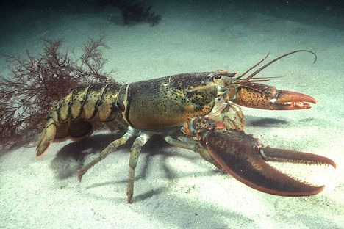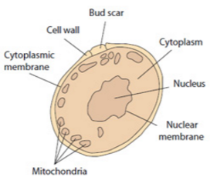

- Metabolism
Metabolism refers to all the chemical reactions in a cell that sustain it. There are two kinds: catabolism (breaking down) and anabolism (building). Generally speaking, catabolism produces energy and anabolism uses up energy. The breakdown of sugar by yeast results in the formation of carbon dioxide gas (CO₂) and ethanol.
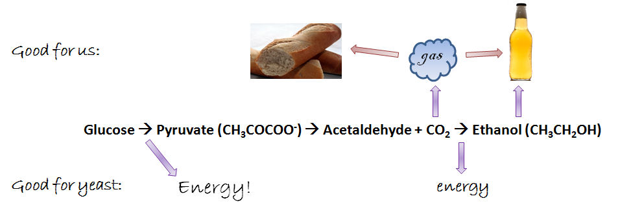

- Reproduction
Eukaryotic cells generally reproduce asexually. This involves a process called mitosis. Here, the nucleus with its DNA replicates itself, then the cell splits with one nucleus going into each of the daughter cells. In yeast, the division is unequal causing the formation of a bud which eventually grows to full size and falls off the parent, leaving a bud scar.

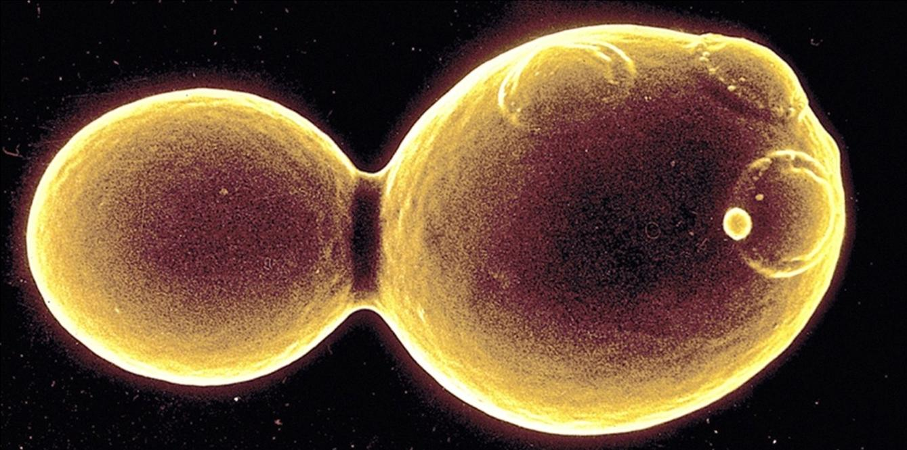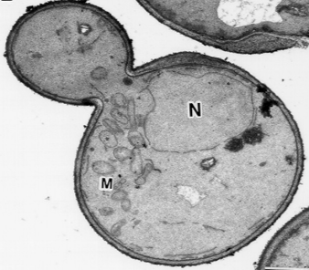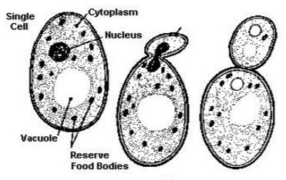

- Scientific Tests: generating evidence to support the claim

Your claim is that dried yeast are alive.

You will perform a series of tests. Your job is to make observations and record those observations (evidence). Then you will use those observations to make conclusions with regard to the four characteristics of life you are attempting to identify in the dried yeast (reasoning).

It will be extremely important to match each piece of evidence with the particular conclusion (of the four) you want to make.

Conclusion 1: Yeast grow and/or develop
Conclusion 2: Yeast are cells
Conclusion 3: Yeast metabolize
Conclusion 4: Yeast reproduce

Test 1
Summary: Attempt to cultivate yeast cells on agar plates containing the sugar glucose. Individual cells that are living will reproduce to form colonies containing millions of cells.
Compare your results with yeast cells plated on agar plates lacking glucose (no reproduction expected).
Procedure:
Place several grains of dried yeast onto each of two plates: agar containing glucose and agar not containing glucose. Let sit for 15 minutes on the table top. Spread across the plate with a sterile, cool loop using many strokes in multiple directions.

Results: What did you observe?

Conclusion with reasoning: Which characteristic of life does this prove and why?

Test 2
Summary: Examine yeast cells from dried granules under the microscope in the presence of a blue dye (stain) that is metabolized (broken down) by yeast, making it colorless when inside a living cell, but colored when inside a dead cell.

Procedure:
Pipet one drop of water onto a clean glass slide. Drop one grain of yeast into the drop. Stir with the loop. Pipet one drop of methylene blue stain onto the yeast. Place a clean coverslip on top. Absorb any excess moisture by touching the edge of the coverslip with the corner of a paper towel. Place the slide on the microscope stage. Examine the slide at 4X first, then 10X, then 40X in that order.

Result A:

Conclusion A with reasoning: Which characteristic of life does this prove and why?

Result B:

Conclusion B with reasoning: Which characteristic of life does this prove and why?

Test 3
Summary: Examine yeast cells from a colony on your agar plate. Attempt to observe budding.

Results: What did you observe?

Conclusion with reasoning: Which two characteristics of life does this prove and why?

Test 4
Summary: Mix yeast granules with water samples containing two different concentrations of glucose. Also a third water sample lacking glucose will be included by the instructor – this is your negative control. Compare the rate of gas production (CO₂).
Research Question:
Does yeast metabolize sugar and produce a gas?

Predictions:
Do you expect yeast to produce a gas when sugar is available? ______

Do you expect yeast to produce a gas when no sugar or other food is available? _____

Explain the reasons for your predictions:

Procedure:
You are given two fermentation bottles with stopper and attached tubing and pipet.
- Using a graduated cylinder, pour 100ml hot tap water into each of the two bottles.
- Weigh out 0.2g of glucose in a weigh boat and pour into the bottle labeled “0.2%”
- Weigh out 1.0g of glucose in a weigh boat and pour into the bottle labeled “1.0%”
- Swirl both bottles until the glucose is completely dissolved.
- Weigh out 4.0g yeast granules in a weigh boat and pour into the bottle labeled “0.2%”.
- Repeat for the bottle labeled “1.0%”
- Swirl both bottles until the yeast is dispersed evenly.
- Let sit on the benchtop for 15 minutes.
- Insert both pipets into a beaker of water so that they rest at an angle.
- Wait until the bubbles come out of the pipets at an even pace.
- Count the number of bubbles emitted from the pipets in two minutes and record the data below (bubbles/2min). Finally, calculate bubbles/min.

Results:
Sample | Bubbles/2min | Bubbles/min
0.0% glucose
0.2% glucose
1.0% glucose

Conclusion with reasoning: Which characteristic of life does this prove and why? Include in your explanation information on the role of glucose in gas production (hint: cell respiration). Also explain why an increase in glucose concentration increases the rate of production of CO₂.

