Biology Hour_____ Name___________________________________________________
Wexler/Fennelly
Mathematics in Nature: The Fibonacci Series and the Golden Ratio
Date:

Nature is full of mathematics. A mathematician or physicist would say that the universe could be completely described in mathematical terms, if such a thing were possible. Of great interest is the finding that certain numbers are frequently seen in nature and take the form of the Fibonacci Series, named after a 12th century mathematician interested in describing the growth of rabbit populations. Certain length ratios are also commonly seen in nature; these ratios are almost identical and are termed the Golden Ratio. For example, they are seen in body proportions, the ratio of female to male bees in a hive, and in DNA. The Golden Ratio is also found in art and architecture due to the human mind interpreting it as a paragon of balance and beauty.
In this activity, you are going to explore these phenomena by determining the Fibonacci Series through observation and deducing the relationship between those numbers. You will also find out the reason for the prevalence of Fibonacci numbers in seed clusters and in flower petals. Similarly, you will examine the Golden Ratio.

Part I. The Fibonacci Series
- Pine cone: trace clockwise and counterclockwise seed spirals using two differently colored markers. Count the number of each and record: Clockwise _________ spirals
Counterclockwise ________ spirals

- Apple core:
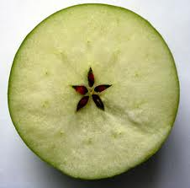 _________ seed pockets in a layer
- Trillium:
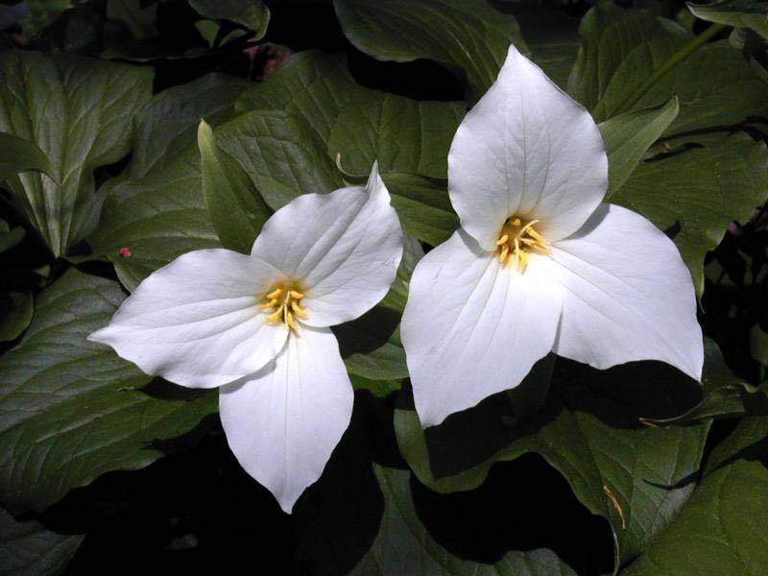 ________ petals in a flower

- Sunflower
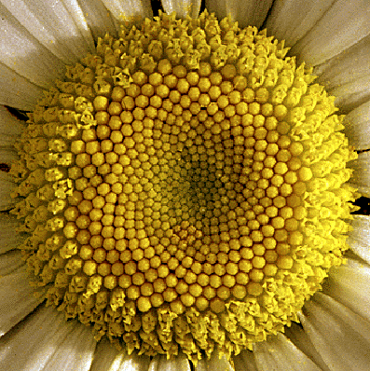

# Clockwise spirals = __________

# Counterclockwise spirals = __________

Summarize observed Fibonacci numbers from lowest to highest:

______, ______, ______, _______, _______, _______
a b c d e f

What is the mathematical basis for the progression of numbers in this series?

Part II. The Golden Ratio

- Calculate the ratio of each Fibonacci number listed above to its preceding number.
1. b/a = _________
2. c/b = _________
3. d/c = _________
4. e/d = _________
5. f/e = _________

- Calculate the Golden Ratio using the following procedure:
- Pick any nonzero number at random.
Take its reciprocal and add 1. Take the reciprocal of this new number and add 1. Keep repeating until the reciprocal + 1 no longer changes – this is the Golden Ratio = ______________
- Repeat this procedure with a different random number of any size. What do you find? Are the two results about the same?

- Draw a diagonal in the pentagon shown below:

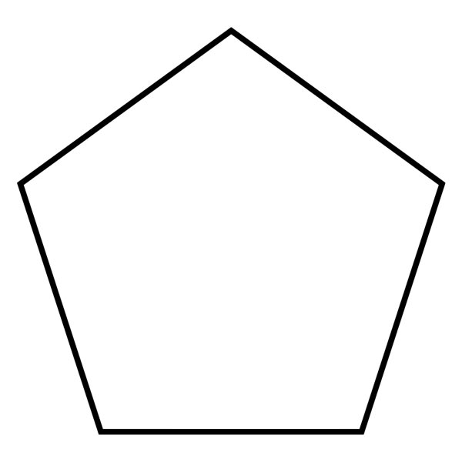
Measure the length of the diagonal = __________________ cm

Measure the length of a side = _________________ cm

Calculate the ratio of the diagonal length to the side length:

Is this close to the Golden Ratio? (yes or no)
- Measure your height in centimeters = ______________ cm

Measure the distance from your navel to the bottom of your foot (when you are standing up) in centimeters = ______________ cm

- Calculate the ratio of these two measurements = body height ÷ navel height = ____________
Is this close to the Golden Ratio? _____________ (yes or no)

Part III. Discussion
Use internet resource(s) to briefly explain in your own words (do not plagiarize) why pine cone seeds and sunflower seeds have evolved to exhibit Fibonacci numbers in their spirals. Be sure to site your resource (s) (author, date, URL)

