Biology Hour_____ Name________________________________________________
Wexler/Fennelly
Nutrient Cycles Worksheet
Date:
Learning Objectives
- Outline the paths of carbon, nitrogen, and water through the ecosystem.
- Explain how the recycling of nutrients sustains life on Earth.
- Predict the effects on living organisms when the nutrient cycles are disturbed.
Prerequisites
- Students should have some basic knowledge of ecology
- Students should have an understanding of photosynthesis and cellular respiration.
- Students should have knowledge of the chemistry of organic macromolecules such as carbohydrates, lipids, proteins, and the nucleic acids.
Why?
We have learned the importance of recycling our trash. It allows us to use something again for another purpose and prevents the loss of natural resources. But what happens to the waste in nature? Why aren’t we up to our necks in natural refuse? Why is there always a supply of water? Why is there oxygen to breathe and carbon dioxide for photosynthesis? Organic compounds in nature are also recycled. This recycling process converts the complex organic compounds to simpler compounds, which then can be returned to nature to be used again and again.

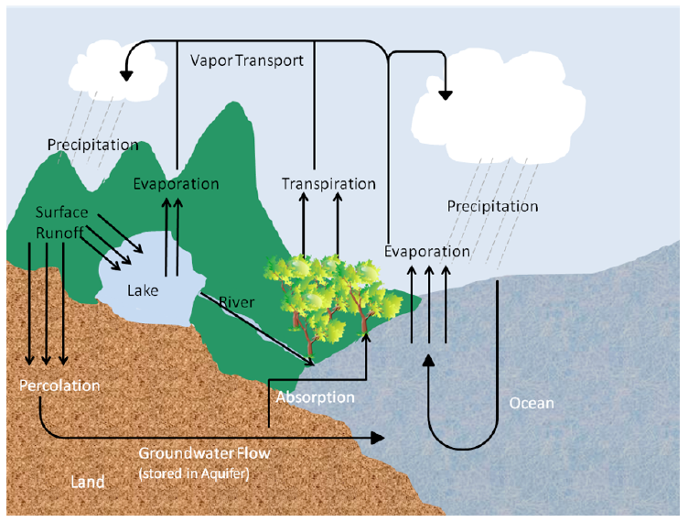
Model 1: The Water Cycle

- Model 1 illustrates how nature recycles what natural resource?

- Model 1 illustrates four major areas of water storage on Earth. Complete the list of these storage areas below.

- Where is groundwater stored?

- Name two process in Model 1 in which water is converted to vapor.

- Describe two methods by which water on land (in lakes and rivers) returns to the oceans.

- Rain, sleet, and snow are examples of what?

- If the air contains high levels of pollutants, what effect might this have on water quality? How does this happen?

- Which part of the water cycle (choose from: precipitation, evaporation, runoff, percolation and transpiration) contributes most to the addition of pollutants to rivers, lakes, and oceans? Explain.

- Which three parts of the water cycle (choose from: evaporation, runoff, percolation and transpiration) help clean or filter the water? Explain for each.

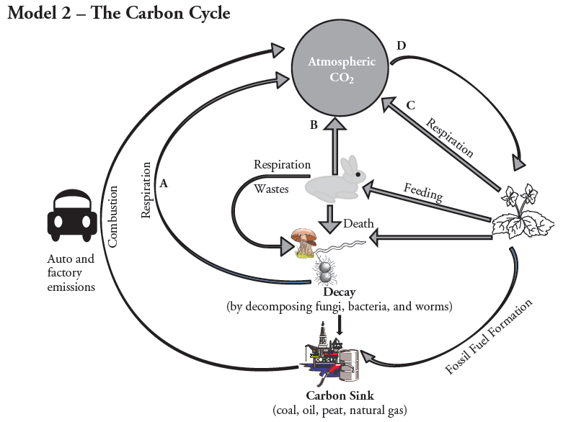

- Model 2 illustrates how nature recycles what natural resource?
- Name two ways that carbon (usually in the form of CO₂) enters the atmosphere.
A.
B.

- Process D on the diagram uses CO₂ from the atmosphere.
- Next to D on the diagram: Write the name of this process (hint: it requires light)
- What two types of organisms carry out this light-requiring process?
i.
ii.

- Wastes and dead organisms must be broken down in order for their components to be used again.
- What organisms in the cycle carry out this process?

- What would happen if decomposition did not occur?

- Not all dead organisms are acted on by decomposers. Instead of being immediately recycled, the carbon from some organisms is kept in a type of long-term storage, or carbon sink. Using Model 2, answer the questions below about this long-term storage.
- List four materials that contain this stored carbon.

- What is the industrial term used for these kinds of materials?

- How do humans use the materials in the carbon sink?

- List five examples of combustion in everyday life.
A.

B.

C.

D.

E.

- What are the different ways in which electricity can be generated?

- Many of the carbon-based fuels are categorized as fossil fuels because they were formed from decayed organisms over millions of years. List the different types of fossil fuels:

- How does our use of fossil fuel carbon stores affect the amount of CO₂ in the atmosphere?

Research Essay!
Carbon dioxide (CO₂) is one of the so-called greenhouse gases. These gases hold heat energy in the atmosphere, which raises the overall temperature of the Earth. This helps maintain the Earth’s biosphere, but also has led to environmental concerns. If too much CO₂ is in the atmosphere, Earth’s average temperature will climb higher than the biosphere can sustain.
- What are the ways in which human activities increase the amount of atmospheric CO₂, and what are potential global effects of these changes in CO₂ levels?

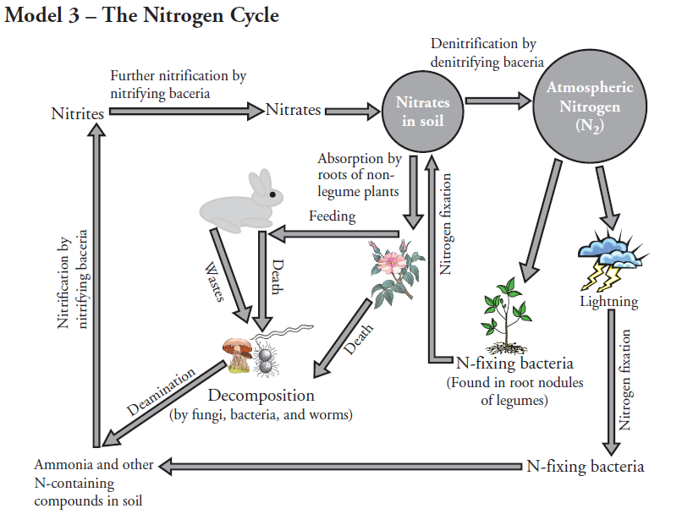
- Model 3 illustrates how nature recycles what natural resource?

- Name 4 ways in which bacteria are involved in the nitrogen cycle.

Read This!
Nitrification is a process by which specific bacteria convert different forms of N-containing compounds (like ammonia, NH₃) in the soil to nitrates (NO₂) and nitrites (NO₃). This process is important since the only forms of nitrogen that are usable by plants to build their proteins are the nitrates.

- How is N₂ gas removed from the atmosphere?

- By what process are animal wastes and dead organisms converted to other nitrogen-containing compounds?

- What is the only form of nitrogen that nonlegume plants can use?

- What do the denitrifying bacteria do during the denitrifying process?

