Biology Hour_____ Name_____________________________________________
Wexler/Fennelly
Lab: Population Genetics of PTC Tasting
Date:
Background:
In 1931, a chemist named Arthur Fox was pouring some powdered PTC into a bottle. When some of the powder accidentally blew into the air, a colleague standing nearby complained that the dust tasted bitter. Fox tasted nothing at all. Curious how they could be tasting the chemical differently, they tasted it again. The results were the same. Fox had his friends and family try the chemical then describe how it tasted. Some people tasted nothing. Some found it intensely bitter, and still others thought it tasted only slightly bitter.
Soon after its discovery, geneticists determined that there is an inherited component that influences how we taste PTC. Today we know that the ability to taste PTC (or not) is conveyed by a single gene that codes for a taste receptor on the tongue. The PTC gene, TAS2R38, was discovered in 2003.There are two common forms (or alleles) of the PTC gene, and at least five rare forms. One of the common forms is a tasting allele, and the other is a non-tasting allele. Each allele codes for a bitter taste receptor protein with a slightly different shape. The shape of the receptor protein determines how strongly it can bind to PTC. Since all people have two copies of every gene, combinations of the bitter taste gene variants determine whether someone finds PTC intensely bitter, somewhat bitter, or without taste at all.
Although PTC is not found in nature, the ability to taste it correlates strongly with the ability to taste other bitter substances that do occur naturally, many of which are toxins.
Plants produce a variety of toxic compounds in order to protect themselves from being eaten. The ability to discern bitter tastes evolved as a mechanism to prevent early humans from eating poisonous plants. Humans have about 30 genes that code for bitter taste receptors. Each receptor can interact with several compounds, allowing people to taste a wide variety of bitter substances.

Studies indicate that individuals with the "supertasters" PTC gene variant were less likely to be smokers. This may indicate that people who find PTC bitter are more likely than non-tasters to find the taste of cigarettes bitter and may be less likely to smoke.
Other studies suggest that there may be correlations between the ability to taste PTC and preferences for certain types of foods. This may be why some of us think that broccoli is just too bitter to eat.

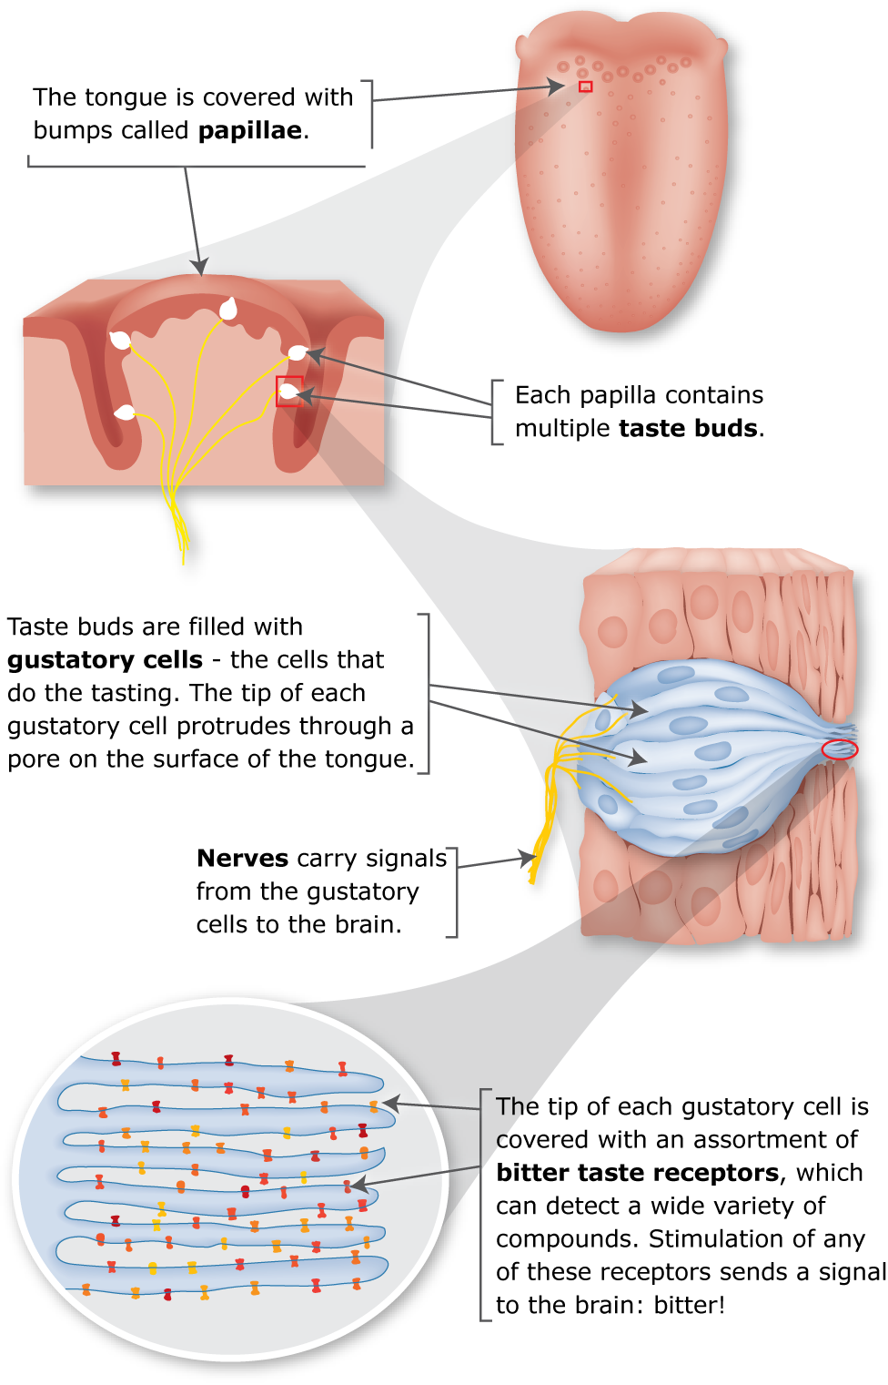
Expected Genotype Frequencies:
The compound phenylthiocarbamide(PTC) tastes very bitter to most persons. The inability to taste PTC is controlled by a single recessive gene. In the American white population, about 70% can taste PTC while 30% cannot (are non-tasters).
Calculate the estimated frequencies of the Taster (T) and nontaster (t) alleles in this population as well as the frequencies of the diploid genotypes:
- Allele frequencies
allele t) q² = 0.30, so the frequency of the recessive allele t = square root of 0.30 = 0.5477 (about 55%)
allele T) p = 1 - q = 1 - 0.5477 = 0.4523 (about 45%)
- We expect the following genotype frequencies:
TT = p² = (0.4523)² = 0.2045 (about 20%)
Tt = 2pq = 2(0.4523)(0.5477) = 0.4956 (about 50%)
tt = q² = (0.5477)² = 0.2999 (about 30%)
Incomplete Dominance in PTC tasting:
Heterozygotes for PTC tasting have half the number of bitter taste receptors on their tongue. Correspondingly, they find the taste of PTC to be “somewhat bitter”, but not intensely so. Reporting of PTC taste is subjective and subject to other variables such as exposure to food or candy or even the time of day.
Procedure and Observations:
You will record both your own data as well as class data in the table below:
Population Size (n) = ___________
Table 1 | Supertaster (TT) | Moderate Taster (Tt) | Nontaster (tt)
Your Data: Are you a…
Class Population Raw Data
Genotype Frequencies
(Show calculations: Raw Data ÷ n)

Results:
Show all calculations!
Keep in mind that “moderate tasting” could reflect Tt or TT. Nontasting (tt) is the genotype most accurately assessed. From this we can determine the expected frequencies of TT and Tt. We will then compare the data to the calculated frequencies.
- Determine q) calculate the recessive nontaster allele frequency (t) From the nontaster (tt) frequency from Table 1

- Determine p) calculate the dominant taster allele frequency (T) using your value for t as determined above:

- Calculate the predicted homozygous dominant and heterozygous genotype frequencies:
- p² (TT)

- 2pq (Tt)

- Compare actual homozygous dominant and heterozygous genotype frequencies with your predicted frequencies
Table 2 | Predicted values | Actual values from Table 1
Frequency TT (supertaster)
Frequency Tt (moderate taster)

Note that any differences between predicted and actual values reflect both subjectivity of reporting as well as confounding variables as mentioned earlier in terms of other genes and environmental factors.

- The nontaster frequency varies according to population, with 25-30% nontaster for European populations, about 15.5 % for the Non-Hispanic African American population, and as little as 2% for Native Americans.
Since our class is predominantly African American, how does the non-taster genotype frequency that you calculated using class data (q²) compare with the published frequency of 15.5%?

