Biology Hour_____ Name____________________________________________
Wexler/Fennelly
Which Symbiosis is it?
Date:
Instructions: Read each description, then write the names of the two organisms in the provided spaces. For each organism indicate if it was helped by the relationship, harmed, or not affected. Finally, write the type of symbiotic relationship, choosing from “mutualism”, “commensalism”, and “parasitism”.
- Oxpecker and zebras: Oxpeckers are a type of small bird that land on zebras and eat ticks and other parasites that live on the zebra’s skin. The oxpeckers get food and the zebras get pest control.
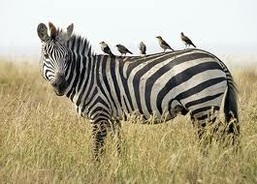
Organism 1___________________________________________ helped harmed not affected

Organism 2___________________________________________ helped harmed not affected

Symbiotic Relationship____________________________________________

- Tapeworm and mammals: Tapeworms are segmented flatworms that attach themselves to the insides of the intestines of animals such as cows, pigs, and humans. Tapeworms get food by eating the host’s partly digested food, depriving the host of nutrients.
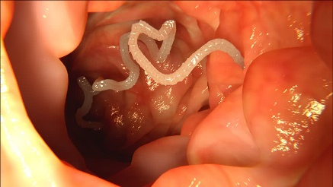
Organism 1___________________________________________ helped harmed not affected

Organism 2___________________________________________ helped harmed not affected

Symbiotic Relationship____________________________________________

- Spider crab and algae: Spider crabs live in shallow areas of the ocean floor, and greenish-brown algae live on the crabs’ backs, helping the crabs to blend in with their environment and therefore unnoticeable to predators. 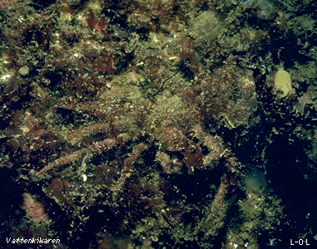
Organism 1___________________________________________ helped harmed not affected

Organism 2___________________________________________ helped harmed not affected

Symbiotic Relationship____________________________________________
- Remora and sharks: Remora fish are small fish that make their niche by picking up scraps of food that sharks leave behind while feeding. The sharks make no attempt to prey on the remora fish.
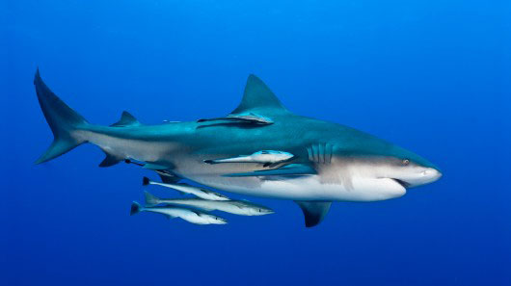
Organism 1___________________________________________ helped harmed not affected

Organism 2___________________________________________ helped harmed not affected

Symbiotic Relationship____________________________________________

- Bee and the flower: Bees fly from flower to flower, gathering nectar which they make into food (honey). When they land in a flower, the bees inadvertently capture some pollen on their body hairs and leg pollen sacs. When they land in a different flower of the same species, some of the pollen from the first one pollinates it.
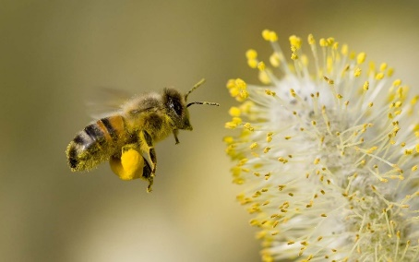
Organism 1___________________________________________ helped harmed not affected

Organism 2___________________________________________ helped harmed not affected

Symbiotic Relationship____________________________________________

- Bacteria and the human colon: Bacteria live in the intestines (colon) of humans where they assist food digestion and produce vitamins B and K. In turn, they absorb nutrients to assist their own growth.
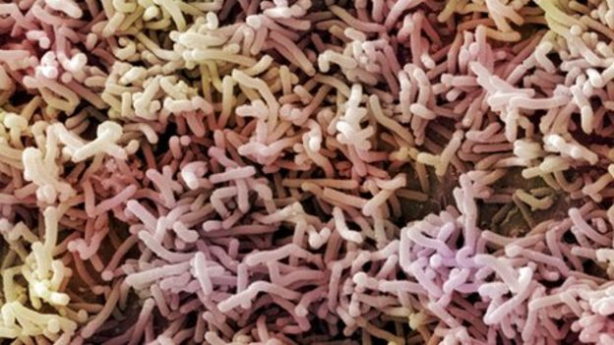
Organism 1___________________________________________ helped harmed not affected

Organism 2___________________________________________ helped harmed not affected

Symbiotic Relationship____________________________________________

