Biology Hour_____ Name______________________________________________
Wexler/Fennelly
Transformation of E. coli with pGLO
Date:
Background
The pGLO plasmid is an engineered plasmid used in biotechnology as a vector for creating genetically modified organisms. The plasmid contains several reporter genes, most notably the gene for green fluorescent protein (GFP) and the ampicillin resistance gene. A reporter gene acts by producing a protein that can be easily measured, such as fluorescence or allowing growth in the presence of antibiotic (see diagram below).
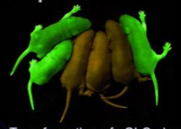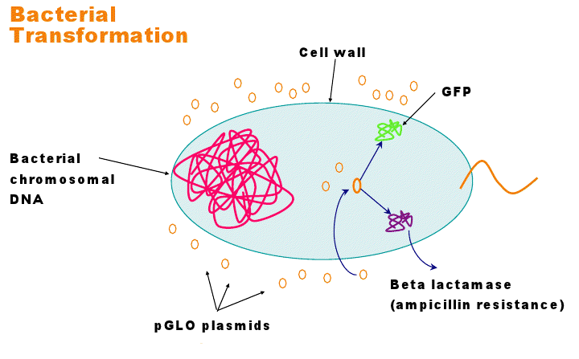
The gene map of the pGLO plasmid is shown here:
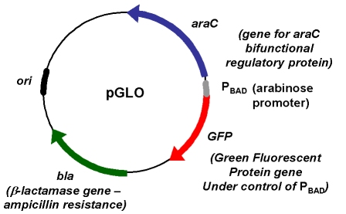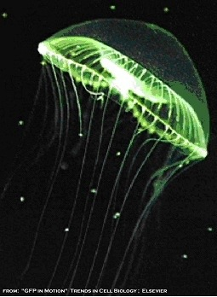
In order to clone a gene, the gene of interest is cut from its original DNA source using restriction enzymes and then pasted into the plasmid by ligation. The plasmid containing the foreign DNA insert is now ready to be transferred into bacteria. This process is called transformation.
Transformed bacteria containing the pGLO plasmid will grow in the presence of ampicillin antibiotic (due to the bla gene product which destroys ampicillin). The GFP gene produces green fluorescent protein, which glows a bright green when exposed to UV light. The sugar arabinose is necessary for the GFP gene to be expressed.
Procedure
In the calcium chloride heat shock method for transformation, E. coli cells are treated with calcium chloride, which helps plasmid DNA attach to their surface. When heated briefly (heat shock), pores open in the bacteria cell wall and the DNA is able to pass through them into the cytoplasm.
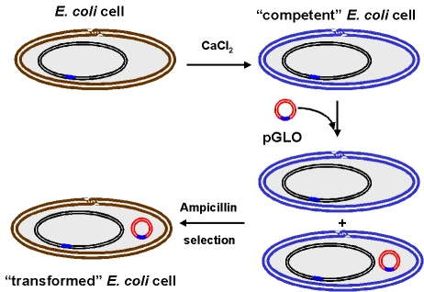

- You are given 250 ul of CaCl₂ (ul = microliter = 1/1000,000 liter
- Place the tube of CaCl₂ on ice and stir in a colony of E. coli bacteria. Use sterile technique!
- Add 5 ul pGlo plasmid DNA (see instructor). Note: this is a VERY small volume.
- Leave on ice for 10 minutes.
- Heat shock briefly by placing the tube in a 42C water bath for 50 seconds exactly.\
- Immediately place back on ice, for 2 minutes.
- Add 250 ul of LB (LB is a nutrient broth for growing bacteria)
- Let sit at room temperature for about 10 minutes.
- Pipet 200 ul of this mixture onto an ampicillin/arabinose plate.
- Spread the bacteria with a sterile loop.
- Do the same for a regular plate (no ampicillin/no arabinose)
- Incubate your plates at 37C for three days. Be sure to label the bottom of each plate with your hour and team number and indicate which one contains ampicillin (“amp”)
- Examine the plates after three days. Also look at them on the transilluminator (UV lamp).
Results
- What did you observe on the regular plate?

- Did the regular plate have bacteria that glowed green when exposed to UV?

- What did you observe on the ampicillin plate? (how many bacterial colonies?)

- Did the colonies on the ampicillin plate glow green when exposed to UV?

- Were there any colonies that did not glow?

Research Question
Full internet address (URL) of the source material for your answer: ____________________________________________
You have just learned that the GFP gene is a reporter gene that fluoresces a bright green when exposed to UV light. In the space below (and any additional space you need), summarize different ways GFP has been used in research or some other application, including art.
Caution: Use your best grammar and be original (use your own words!) Do not work together with anyone else (use a different URL than your friends!) This is due on Tuesday of next week. Don’t wait for your results on Monday – at least start this over the weekend. Yes, you will also have Monday in class, but it is probably a bad idea to wait until the last minute since you will be rushed.
Hint: Type “Applications of Green Fluorescent Protein” into the Google search box. You may use Wikipedia to get ideas, but do not use it as your source – the article is too technical. Look for articles that are for the lay person, for example - http://www.livescience.com/16752-gfp-protein-fluorescent-nih-nigms.html or http://www.conncoll.edu/ccacad/zimmer/GFP-ww/cooluses1.html are suitable. There are many articles, so find your own!
AD = Well organized and original writing, few grammar and spelling mistakes, three or more applications of GFP discussed.
PR = average writing (some grammar and spelling mistakes), but original, three or more applications of GFP discussed.
BA = Less than three applications of GFP discussed.
MI = Poor writing, lack of detail, less than three applications of GFP discussed.

