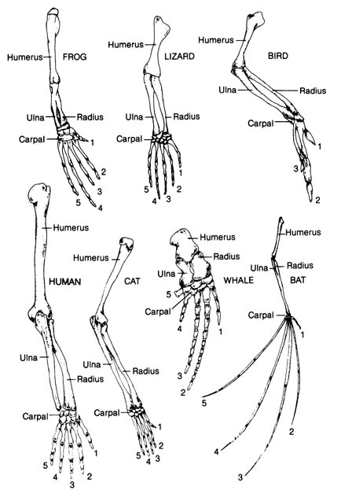
Color code the following appendages
COLOR KEY
Humerus Ulna Radius

Carpal Phalanges

Questions: Answer the following questions using the colored forelimb pictures (on the front).
- What are the functions of the appendages?

Appendage | Function
Frog arm
Lizard arm
Bird wing
Human arm
Cat arm
Whale fin
Bat wing

- Do any of the 7 animals (including humans!) use the appendages in the same way? Use specific examples.

- Each organism has finger bones even if they do not have fingers. What is the term for structures like these?

- Which 2 animals have the most in common? (look at the number of bones and relative size of bones). What does this tell you about their ancestry?

- What structures in a bat’s wing & human’s arm are homologous?

- How are the structures in a whale’s fin & bird’s wing similar?

- Assuming the human, whale, and bat had a fairly recent common ancestor, what evolutionary pressures could have resulted in the divergence in body form and skeletal structure that we see today?

